**Database Schema for Traffic Offence Reporting and Resolution Platform**

#### 1. Users Table

This table stores the basic information of all users (both admins and drivers).

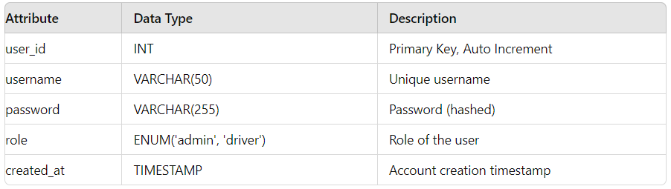

#### 2. Admins Table

This table stores additional information specific to admin users.

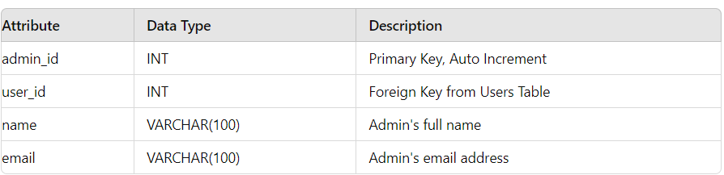

#### 3. Drivers Table

This table stores additional information specific to driver users.

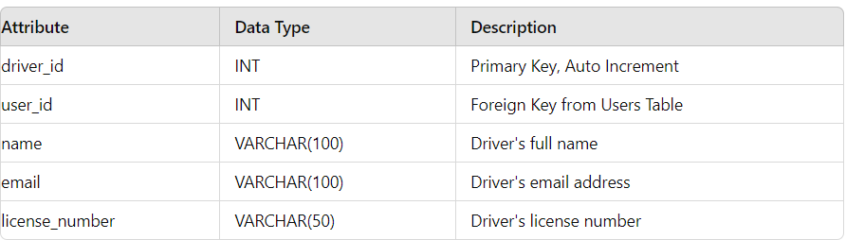

#### 4. Vehicles Table

This table stores information about the vehicles owned by drivers.

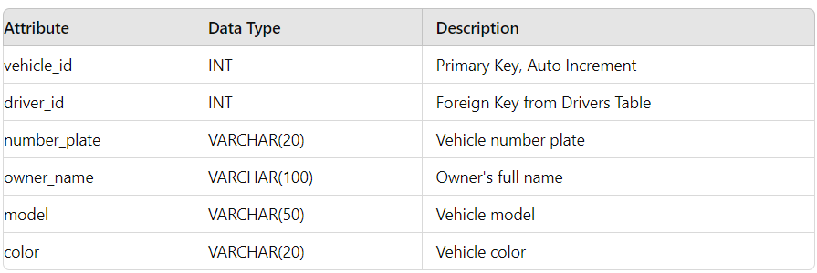

#### 5. Complaints Table

This table stores complaints reported by admins against vehicles.

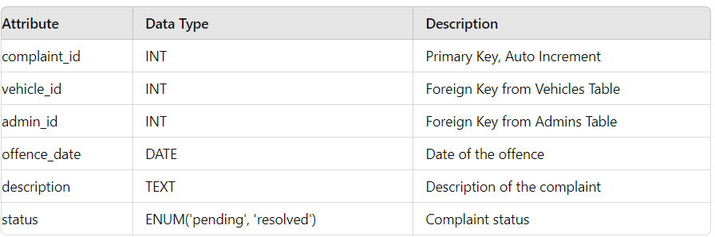

#### 6. Offences Table

This table stores details of the specific offences related to a complaint.

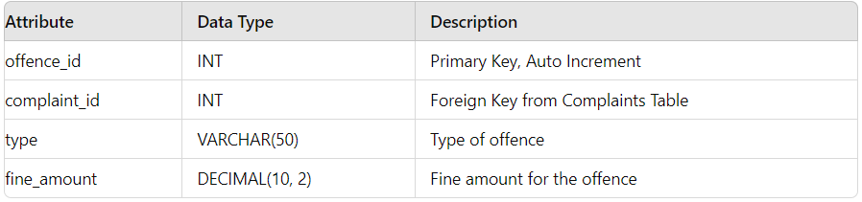

#### 7. Payments Table

This table tracks the payments made by drivers to resolve complaints.

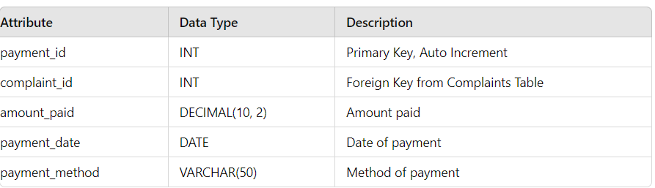

### Relationships and Diagram

- **Users and Admins/Drivers**: The `Users` table connects to both the `Admins` and `Drivers` tables through the `user_id` attribute.

- **Drivers and Vehicles**: Each driver can own multiple vehicles, linked through the `driver_id` attribute in the `Vehicles` table.

- **Vehicles and Complaints**: Each vehicle can have multiple complaints, recorded in the `Complaints` table and linked via the `vehicle_id` attribute.

- **Complaints and Offences**: Each complaint can consist of multiple offences, detailed in the `Offences` table and linked via the `complaint_id` attribute.

- **Complaints and Payments**: Each complaint can have multiple payments, tracked in the `Payments` table and linked via the `complaint_id` attribute.

```plaintext

+-----------+ +--------+ +-----------+

| Users | | Admins | | Drivers |

+-----------+ +--------+ +-----------+

| user_id |---------| user_id| | user_id |

| username | | name | | name |

| password | | email | | email |

| role | +--------+ | license_number|

| created_at| +-----------+

+-----------+

+-----------+ +-------------+

| Vehicles | | Complaints |

+-----------+ +-------------+

| vehicle_id | | complaint_id|

| driver_id |------------| vehicle_id |

| number_plate| | admin_id |

| owner_name | | offence_date|

| model | | description |

| color | | status |

+-----------+ +-------------+

+------------+

| Offences |

+------------+

| offence_id |

| complaint_id|

| type |

| fine_amount |

+------------+

+-------------+

| Payments |

+-------------+

| payment_id |

| complaint_id |

| amount_paid |

| payment_date |

| payment_method|

+-------------+

```

### Explanation:

1. **Users Table**:

- Stores user credentials and roles.

2. **Admins and Drivers Tables**:

- Store additional details specific to admins and drivers.

3. **Vehicles Table**:

- Stores vehicle information, linked to drivers.

4. **Complaints Table**:

- Stores complaints against vehicles, linked to admins and vehicles.

5. **Offences Table**:

- Stores details of offences for each complaint.

6. **Payments Table**:

- Tracks payments made for resolving complaints.